

**AMERICAN INTERNATIONAL UNIVERSITY–BANGLADESH (AIUB)**

**FACULTY OF SCIENCE & TECHNOLOGY**

**DEPARTMENT OF PHYSICS**

**PHYSICS LAB 1**

**Summer 2020-2021**

**Section: J , Group: 1**

**LAB REPORT ON**

### **Verification of Newton's Second Law of motion by Atwood’s Machine**

**Supervised By**

**BITHI PAUL**

**TABLE OF CONTENTS**

|  |  |
| --- | --- |
| **TOPICS** | ***Page no*.** |
| 1. **Title Page** | 1 |
| 1. **Table of Content** | 2 |
| 1. **Theory** | 3 |
| 1. **Apparatus** | 4 |
| 1. **Procedure** | 4 |
| 1. **Experimental Data** | 5 |
| 1. **Analysis and Calculation** | 6 |
| 1. **Result** | 7 |
| 1. **Discussion** | 7 |
| 1. **References** | 8 |
|  |  |

**Experiment Name: Verification of Newton's Second Law of motion by Atwood’s Machine**

1. **Theory**

The acceleration of an object starting from rest, and acquiring a final velocity v in time t can be computed from the equation

D =  aex t2

or, aex =  (aex = experimental acceleration) …………… (A)

D

where, D is the distance traveled by the object during time t.

In Atwood’s machine, two masses m, and M are suspended by a piece of inelastic light string that passes over a pulley in a vertical plane. If M > m, the acceleration, a, with which the whole system moves is given by

ath =  (ath = theoretical acceleration) …………………. (B)

where g is the acceleration due to gravity (9.80 m/s2).

aex = (g / M+m) (M-m)

Fig: Atwood’s Machine

y = mx +c ,slope, m = (g / M+m)

Error of a = $\left(\frac{a_{th}-a_{ex}}{a_{th}}\right)×100$%

1. **Apparatus**
2. Pulley.
3. Two hangers.
4. Different masses
5. String.
6. Stand and clamp.
7. Meter scale.
8. Stop watch
9. **Procedure**

First, we have to hold the lighter mass on the floor attached to one end of a string and keep the heavier one attached to the other end of the string up in the air at a height D from the floor. Then we have to measure D with a meter scale.

Now we have to release the lighter mass and measure the time the heavier mass takes to fall onto the floor. We have to run the experiment for 7 different mass-differences, (M - m). For each run, we obtain the value of the acceleration in (m/s²) experimentally as well as theoretically. We have to make sure to keep total mass (M + m) always constant.

Now using excel we plot acceleration (aₜₕ and aₑₓ) versus mass difference (M - m) graph.

1. **Experimental Data**

**Table: Acceleration for different mass combination.**

|  |  |  |  |  |  |  |  |  |
| --- | --- | --- | --- | --- | --- | --- | --- | --- |
| M  (gm) | m  (gm) | Height  D  (cm) | Time  t  (sec) | Mean  Time  (sec) | aex =  (cm / s2) | ath =  (cm / s2) | %  of Diff,  a= | M - m  (gm) |
| 500 | 200 | 79 | 0.56 | 0.56 | 503.82 | 420 | 19.959 % | 300 |
| 0.57 |
| 0.55 |
| 475 | 225 | 79 | 0.62 | 0.63 | 398.08 | 350 | 13.739 % | 250 |
| 0.63 |
| 0.64 |
| 450 | 250 | 79 | 0.75 | 0.74 | 288.53 | 280 | 3.046 % | 200 |
| 0.74 |
| 0.75 |
| 425 | 275 | 79 | 0.80 | 0.81 | 240.81 | 210 | 14.671 % | 150 |
| 0.83 |
| 0.82 |
| 400 | 300 | 79 | 0.90 | 0.91 | 190.79 | 140 | 36.279 % | 100 |
| 0.92 |
| 0.93 |
| 375 | 325 | 79 | 1.09 | 1.1 | 130.57 | 70 | 86.529 % | 50 |
| 1.10 |
| 1.11 |
| 350 | 350 |  | 0 |  | 0 | 0 | 0 | 0 |

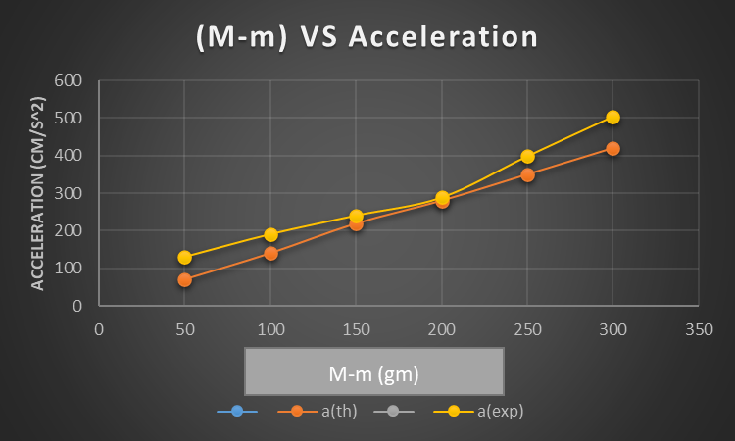

1. **Analysis and Calculation**
2. **The slope of the straight line:**

From the graph-

Slope, $\frac{g}{M+m}$ = 1.4

or, M+m = 700 gm

1. **Error of (M+m) = $\frac{700-700}{700}$** x100% = 0 %
2. **Result**

From the ‘acceleration vs mass difference’ graph, the relationship between experimental acceleration and mass difference is directly proportional linear for the Atwood machine same as the theory says. Thus, we can say that Newton’s second law is verified.

1. **Discussion**

In the Modified Atwood Machine Lab, Newton’s second law relating the net force, mass, and acceleration was examined, as well as how to use frictionless surfaces and objects, along with a pulley, to confirm this relationship. By using the mass of the cart and adjusting the hanging masses, which changes the acceleration of the cart, we can observe Newton’s second law in effect. Overall, the data supports Newton’s second law, as it only deviates from the law slightly, which could be explained by imperfections in the lab setup and the measurements. One peculiarity of the data was that as the mass increased, the difference between observed acceleration and acceleration predicted by Newton’s second law increased. This may able to be explained by the fact that as the mass increases, the force on the pulley by the string increases, which increases the pulley’s friction. This results in the net force on the cart decreasing, which therefore reduces its acceleration and increases its deviation from the prediction. The friction of the pulley being unaccounted for was one possible source of error in the lab. One other could possibly be the track not being at the most ideal angle to allow the gravitational and normal forces to counteract its own friction.

1. **References**

• Fundamental of Physics (10th Edition): Newton’s second law of motion  
(Chapter 5, page 98-109).  
• Video Links:▪ Newton’s second law: https://www.youtube.com/watch?v=xzA6IBWUEDE  
▪ Atwood Machine: https://www.youtube.com/watch?v=a0KVxh8iPP4